Practical – 7

PHP Form Processing with Server-Side Validation and CSV/JSON File Storage
Problem Definition : Process submitted registration/contact form data using PHP. Validate and sanitize inputs on the server side and store records in CSV or JSON file format. Display success/error messages.
A. THEORY
1. Is the form submitted using POST?
Yes. The form uses the POST method to send user data to the PHP server without displaying the data in the URL.
2. Are inputs validated and sanitized server side?
Yes. The PHP code checks the received inputs and validates them before processing. Input data is also cleaned to reduce the risk of unsafe or unwanted data.
3. Is file writing handled safely?
Yes. The submitted data is written to the required file using PHP file-handling functions. The file is opened in append mode so that previous records are not overwritten.
4. Are success and error responses displayed clearly?
Yes. A clear success message is displayed after the form is submitted successfully. If there is an error, an appropriate error message is shown to help the user understand the problem.
References
- PHP Manual – POST Variables
- PHP Manual – Filter Functions
- PHP Manual – File Handling
- OWASP – Input Validation Cheat Sheet

B. Implementation/ Output/Result
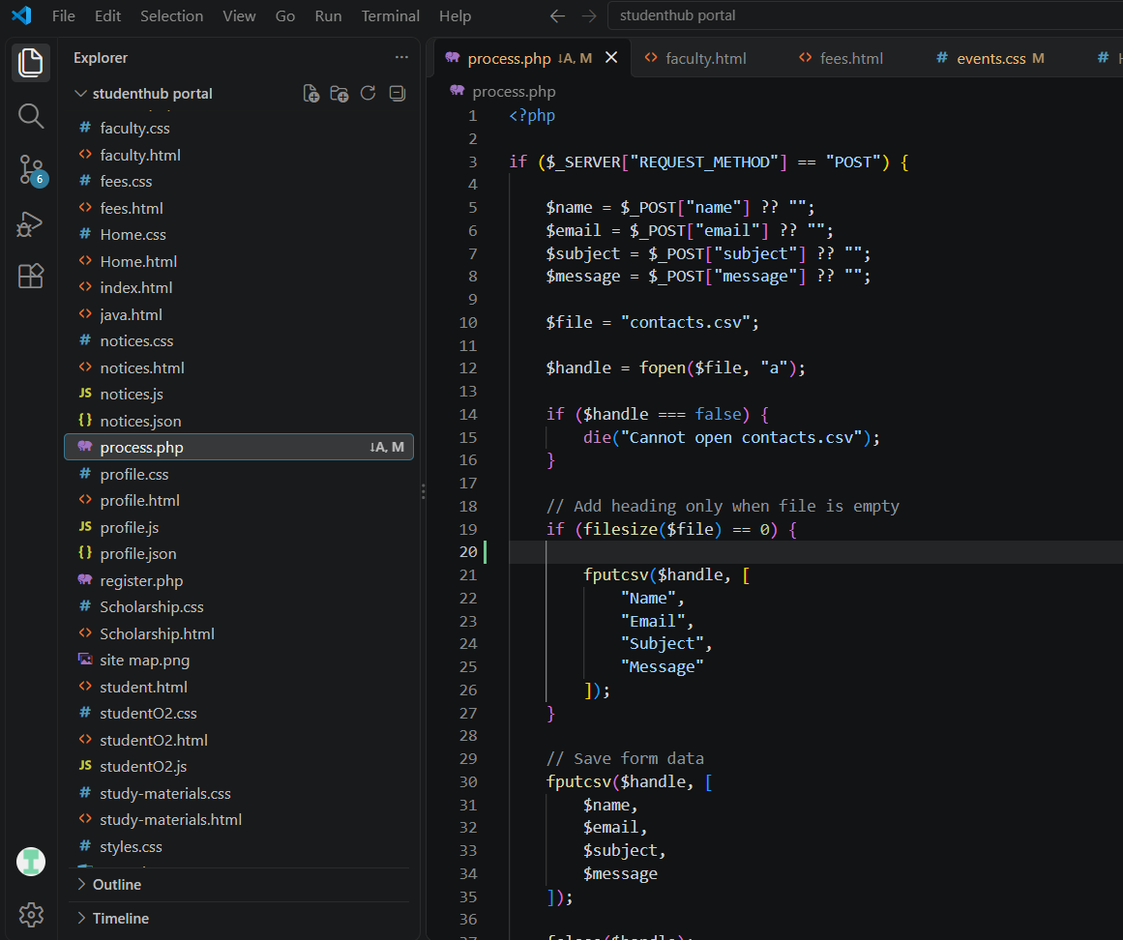

C. Evidence of Work (Screenshots)

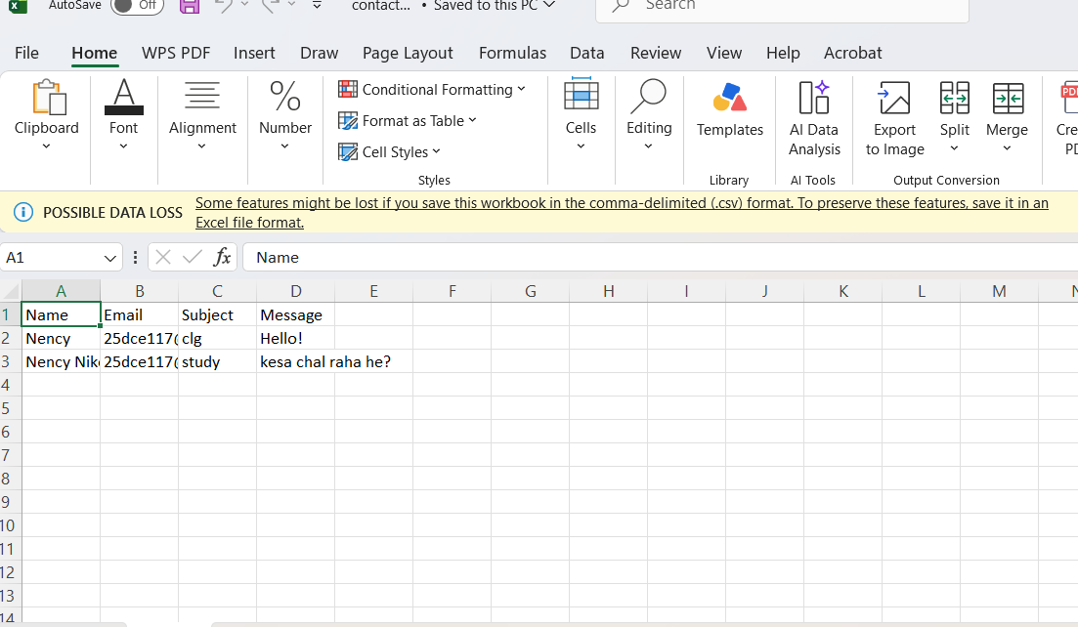

D. GitHub Repository Link
https://github.com/NencyNVagadiya/Student-Hub-portal/blob/main/contact.html

E. Challenges Faced:
“I faced difficulty in receiving and validating form data using PHP and storing the validated records in a CSV file while displaying proper success and error messages” .
F. Learning Outcomes:
Students will implement server-side form processing with safe file-based storage.

G. Faculty Remarks:

